**Green Society Public School**

**D-20**

**Ratnanagar-7, Sauraha, Chitwan**

**First Terminal Examination-2082**

**Class: L.K.G Time: - 2 hrs. F.M.: 50**

**Sub: Project Work P.M.: 18**

|  |
| --- |
| **Name: Roll No.: Sec.:** |
| **­­­­­­­­­­­­ ________________ ______________ OBT.MARKS:**  **INVIGILATOR EXAMINER** |

1. **Color it. [5]**



1. **Draw a beautiful flower and color it. [5]**

1. **Color it. [10]**



1. **Color the same picture. [10]**

** =  **

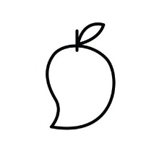 **=** 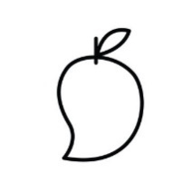 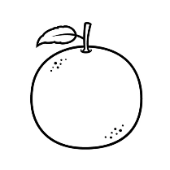

1. 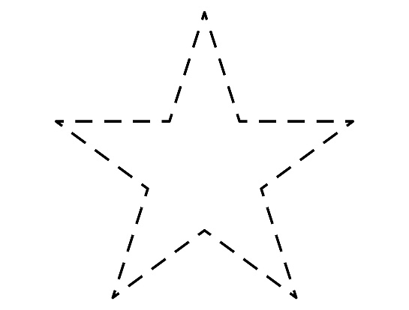**Join the dotted line and color it. [10]**

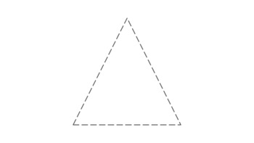

1. **Color the given picture. [10]**



**The End**